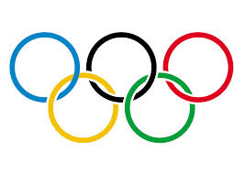

Dublin Games

Summer 2022
Dublin, Ireland
By Abigail Connolly

Dublin at a Glance
Map:
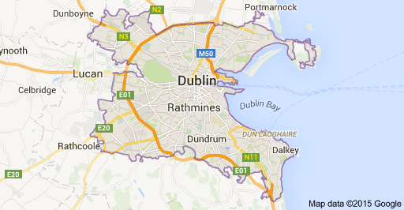

Languages: English and Gaelic

Currency: Euro

Population: 527, 612

Stability: Stable

Government System: Republic of Ireland; Unitary state; constitutional republic; parliamentary system

Leadership: Michael D. Higgins, Head of State

Famous Citizens: Oscar Wilde, Jonathan Swift, James Joyce, Samuel Beckett, U2
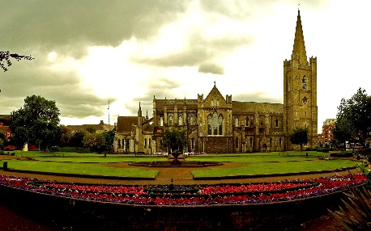
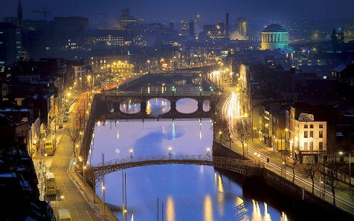
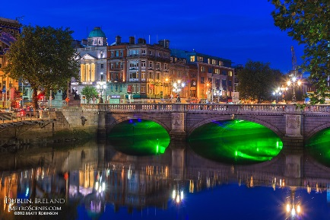

History of Dublin
- 8th and 9th Century: Dublin’s documented history begins with Viking raids in the 8th Century, eventually leading to an established settlement. Dublin continued to be sacked several times over the course of these two centuries, but remained strong and eventually became the most important (and largest; population: 4000) city in Ireland.

- 1169: Beginning of Norman rule (lasts 700 years)
- 1190: Dublin destroyed by fire
- 13th Century: Stone fortress built
- 14th-18th Centuries: Dublin incorporated into the English Crown (“The Pale”)
- 16th Century: Trinity College established by Queen Elizabeth
- 1640-1650: Half of Dublin’s population is wiped out by plague
- 1759: Guinness first brewed
- 1779: Grand Canal built
- 1800: Act of Union-Ireland officially (legally) merged with Great Britain to establish the United Kingdom

- Monday, April 24th, 1916: Easter Rising-Irish nationalists rebel against the British government and declare the establishment of the Irish Republic. Fighting was finally suppressed after a week, and more than 2000 people died. The leaders were executed and eventually hailed as martyrs.

- 1918: War for Independence- Sinn Fein political party elected a majority but refused to sit in UK Parliament. In 1919, they met in Dublin to convene an Irish Parliament, and declared Irish independence. This began a guerrilla war against the British, which lasted until a July 1921 cease-fire.

- December 1921: Treaty establishing Irish Free State
- Monday, April 18th, 1949: Establishment of Republic of Ireland

- Mid-1990s: Dawn of the “Celtic Tiger”- a term for the economic boom that has brought increased industrialization, expansion, and city development to Dublin.

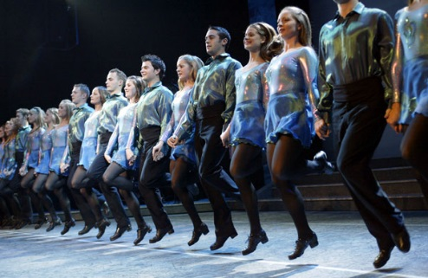
Culture of Dublin
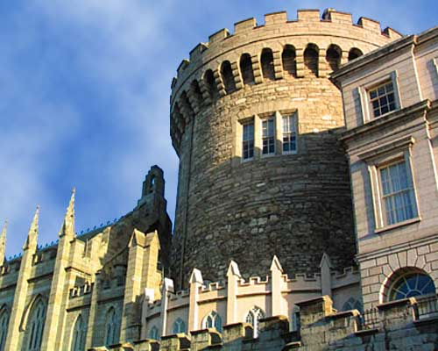
- “City of Living Culture

- “Craic”

- Pubs

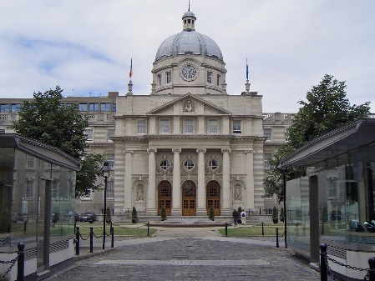
- Music (traditional and contemporary)

- Dance

- Theatre

- Historic houses and gardens

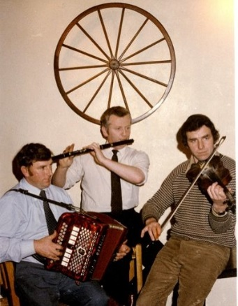
- Films

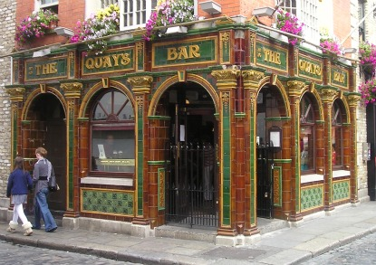
- Museums

- Galleries
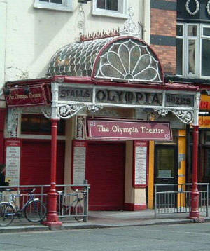

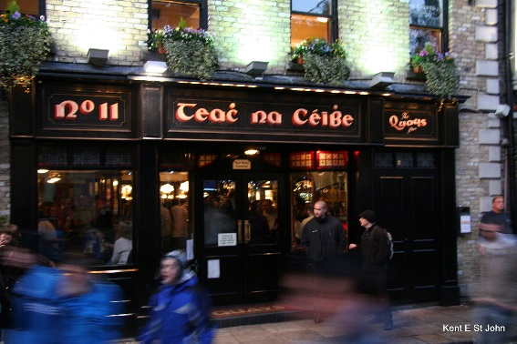

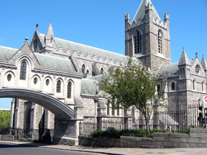

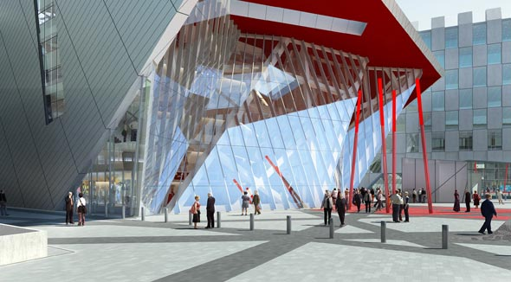

Lodging
- Westbury Hotel
4.2 stars; $363/night
“A 1-minute walk from the bustling Grafton Street, this swanky hotel in the city centre is a 4-minute walk from Trinity College and an 11-minute walk from the National Museum of Ireland.
Luxe rooms have airy interiors with custom wool carpets, chic furnishings and pillow-top mattresses. All come with free WiFi, flat-screen TVs and Nespresso coffeemakers, as well as marble bathrooms with heated floors and designer toiletries. Suites have living areas, with some adding free-standing baths and/or contemporary 4-poster beds.
There's a hip restaurant for modern meals and a sleek cocktail bar, plus a fitness centre and upscale meeting spaces”
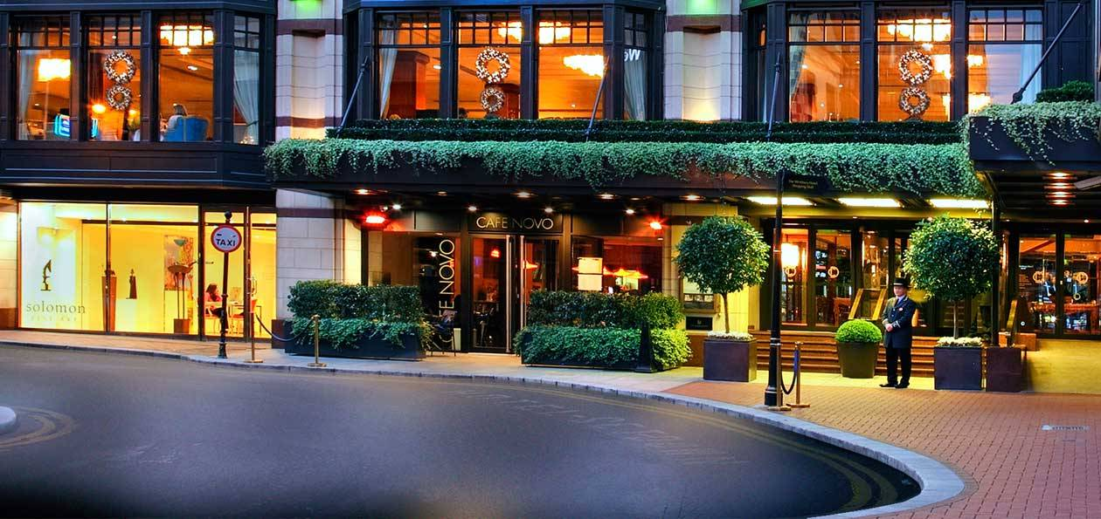
- The Shelbourne Dublin, a Renaissance Hotel
4.5 stars; $309/night
“Overlooking St. Stephen's Green, this palatial hotel is set in a grand 1842 Victorian building with an ornate facade. It's 4 minutes' walk from upscale shopping on Grafton Street, a 5-minute walk from the National Gallery of Ireland and 9 minutes' walk from Trinity College.
Luxe rooms in classical styling feature elegant fabrics and pillow-top mattresses, as well as marble bathrooms. All come with free WiFi, flat-screen TVs with cable channels, and iPad/iPhone docks, plus tea and coffeemaking facilities. Suites add lavish living and dining areas.
Amenities include a chic spa, 2 fine-dining restaurants and a plush lounge for high tea and supper"
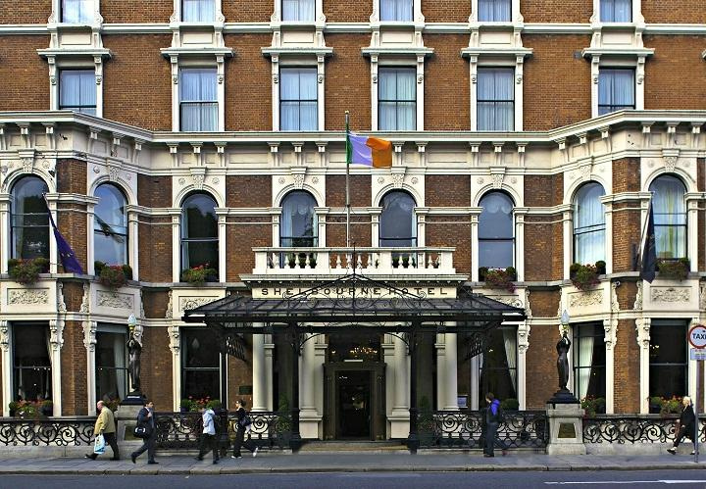
- Maldron Hotel Parnell Square
3.8 stars; $174/night
“On the N1 in the north of Dublins' city centre, this contemporary hotel is a 1-minute walk from Dublin City Gallery, a 5-minute walk from O'Connell Street shopping and a 12-minute walk from the Abbey Theatre.
Featuring modern furnishings and bright accents, the air-conditioned rooms offer WiFi access and flat-screen TVs. All come with desks, plus tea and coffeemaking facilities.
Casual meals and take-out pizzas are served in an informal cafe/bar. Off-street parking is available for a charge.”
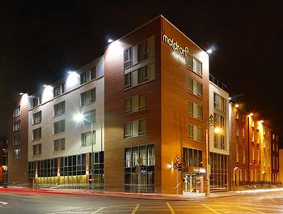

- Royal Marine Hotel
  - stars; $116/night
“Occupying both a modern building and an ornate 19th-century structure with marble columns and a carved wooden staircase, this grand hotel is a 4-minute walk from Dun Laoghaire train station (providing commuter services to central Dublin) and 5 minutes from Dun Laoghaire Harbour.
Posh rooms and suites come with free WiFi, air-conditioning and minifridges. Many have sea views and free-standing tubs.
Dining options include an all-day bistro serving classic Irish cuisine, 3 bars and a lounge. Other amenities include a heated indoor pool, gym and sauna, as well as event/conference facilities. There's also a 9-room spa (fee). Parking is free.”
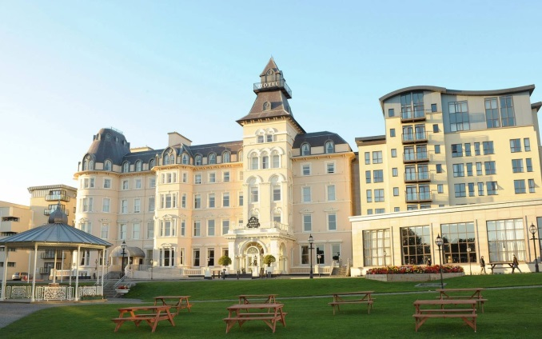
- Radisson Blu Royal Hotel
  - stars; $219/night

“Contemporary rooms with work desks in modern aparthotel with business centre and sleek restaurant.
